Color Control Activity
Project Team:  Alex Herbon  Mike Damman  Andrew Koeck  Scott Miller  Sargon Partners  Jeff Golota  Dan Anthony  Project Advisor:  Dr. Bruce Maxim  Dr. Kiumi Akingbehin | Abstract:  The advent of smart phone applications has led to a growing demand for new, innovative ways for consumers to manage their daily lives. Simple, touch-screen based user interfaces may provide users the convenience of wirelessly controlling their various systems and devices, such as LED lighting setups.  The purpose of our project was to create an application for Android smart phone devices that enables the user to wirelessly adjust LED lighting fixtures. We designed it around building an intuitive UI (see figure 1) and providing multiple features for the user. These include: creating and viewing custom color combinations (using red, green, and blue color), saving and managing these combinations locally on the smart phone device, sending them wirelessly to a lighting control box, and setting brightness and timer settings for the lights.  Our application works with the Android device's Bluetooth functionality to transmit data to a compatible LED lighting control box, provided by our client (see figure 2). In practice, it reliably displays the same color on screen as that which comes out through the lighting fixtures. The software will be bundled and sold with the control box hardware by our client. For more details, go to http://www.lumenilaire.com/index.html.

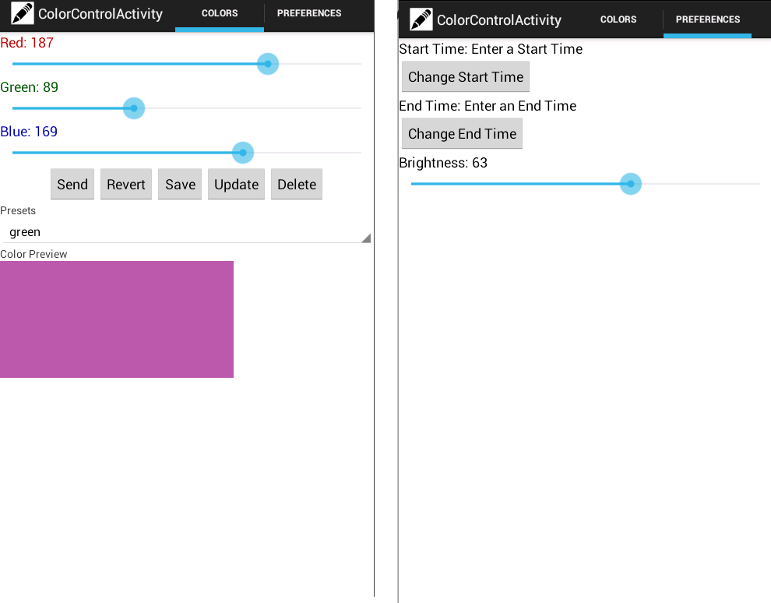 | Figure 1:  The application's UI, displaying the main and preferences tabs.
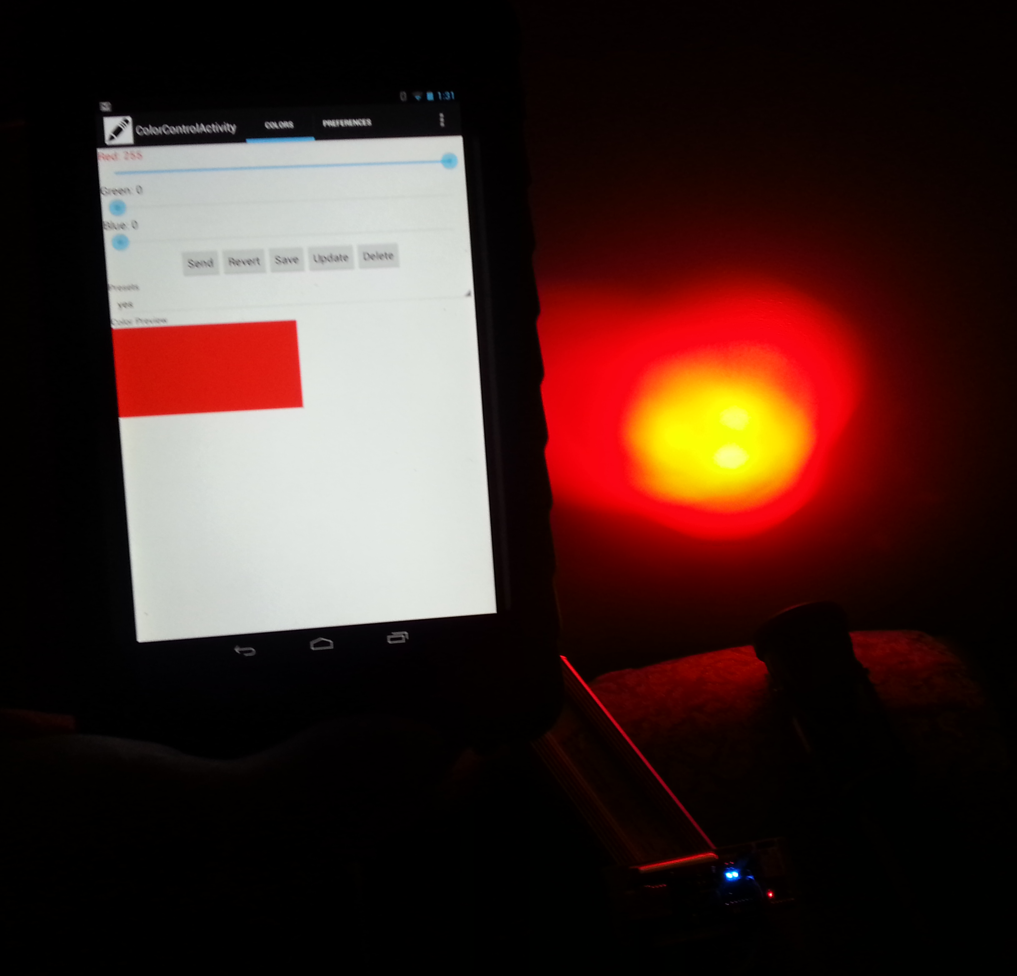 | Figure 2:  An Android tablet running the application and transmitting color data to an RGB LED light via a demo build of the control box hardware.

